**LIBRARY MANAGEMENT SYSTEM**

SQL PROJECT

Name – Kafil Irfan khan

Batch - Data Science and analytics with AI

Branch - Thane

Mob no. - 7378759636

LIBRARY MANAGEMENT SYSTEM

***Project for SQL Module***

**1. Description:**

Following database schema is designed to function as a backend storage database for a web

application built to manage a library.

By storing information in a relational database, all the tasks related to daily functioning of the

library can be performed easily and much more efficiently. Some of the benefits of using this system to

store data over traditional paper registers are as follows:

 Updating and modifying booklist in the library is much easier and efficient

 Maintaining customer details and their account is easy and efficient.

 Calculations like due payments can be done automatically by DBMS, thus eliminating human

error

 RDBMS provides many ways to analyze available data, thus helping in making more informed

decisions about inventory management and other aspects of library management

This database contains 5 tables:

1. Author

2. Type (Genre of book)

3. Book

4. Customer

5. Transaction

How these tables/entities are related to each other is shown pictorially on next page through

ER diagram, i.e., Entity Relationship Diagram.

**2. ER-Diagram (Entity Relation – Diagram) for Library Management System:**

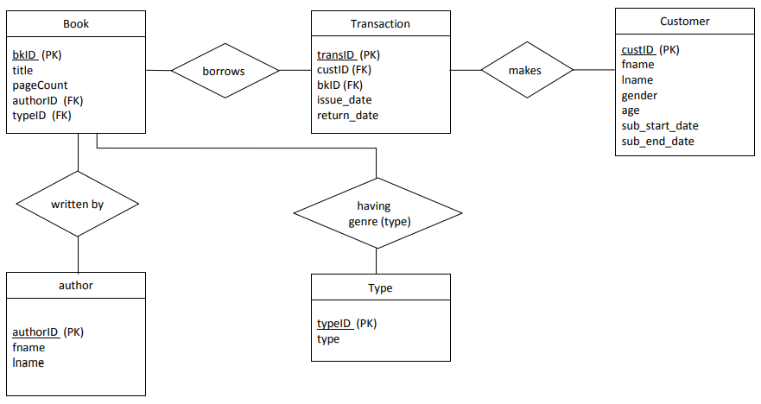

**3. Table Descriptions:**

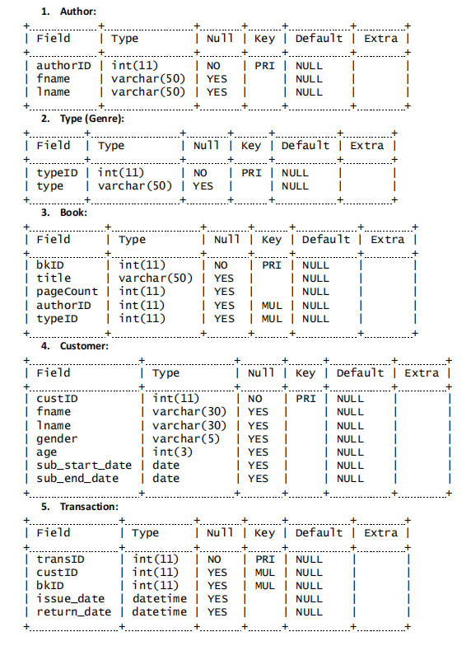

**4. Commands:**

 **Create Database: lms**

 **Select Database: lms;**

 **Create table named author:**

 **Create table named type:**

 **Create table named book:**

PRIMARY KEY (bkID),

CONSTRAINT fk_bk_author FOREIGN KEY (authorID) REFERENCES author(authorID),

CONSTRAINT fk_bk_type FOREIGN KEY (typeID) REFERENCES type(typeID);

 **Create table named customer:**

**Create table named transaction:**

CONSTRAINT fk_trans_cust

FOREIGN KEY (custID)

REFERENCES customer(custID),

CONSTRAINT fk_trans_bk

FOREIGN KEY (bkID) REFERENCES

book(bkID));

 **Populate “author” table:**

INSERT INTO author VALUES

(1, 'William Dean', 'Howells'),

(2, 'Frederic', 'Brown'),

(3, 'Jack', 'London'),

(4, 'Albert', 'Blaisdell'),

(5, 'Ellis', 'Butler'),

(6, 'Arthur', 'Machen'),

(7, 'Titus', 'Lucretius'),

(8, 'Rabindranath', 'Tagore'),

(9, 'Isaac', 'Asimov'),

(10, 'Charles', 'Dickens'),

(11, 'Ralph Waldo', 'Emerson'),

(12, 'Dorothy', 'Canfield'),

(13, 'Givoanni', 'Boccaccio'),

(14, 'George', 'Orwell'),

(15, 'Publius', 'Ovid'),

(16, 'Robert Louis', 'Stevenson'),

(17, 'Virginia', 'Woolf'),

(18, 'George', 'Eliot'),

(19, 'Amelia B.', 'Edwards'),

(20, 'Fyodor', 'Dostoevsky'),

(21, 'Emily', 'Dickinson'),

(22, 'Edna', 'Ferber'),

(23, 'Joseph Sheridan', 'LeFanu'),

(24, 'John', 'DosPassos'),

(25, 'Ruth', 'Stuart'),

(26, 'Vladimir', 'Nabokov'),

(27, 'Johanna', 'Spyri'),

(28, 'Ernest', 'Dowson'),

(29, 'Mary Hallock', 'Foote'),

(30, 'Zane', 'Grey'),

(31, 'H. P.', 'Lovecraft'),

(32, 'Samuel', 'Pepys'),

(33, 'Kate Dickinson', 'Sweetser'),

(34, 'William', 'Lampton'),

(35, 'Mother', 'Goose'),

(36, 'Eleanor Hallowell', 'Abbott');

 **Populate “type” table:**

INSERT into type VALUES

(1, 'Science fiction'),

(2, 'Satire'),

(3, 'Drama'),

(4, 'Action and Adventure'),

(5, 'Romance'),

(6, 'Mystery'),

(7, 'Horror'),

(8, 'Health'),

(9, 'Guide'),

(10, 'Diaries'),

(11, 'Comics'),

(12, 'Diaries'),

(13, 'Journals'),

(14, 'Biographies'),

(15, 'Fantasy'),

(16, 'History'),

(17, 'Science'),

(18, 'Art');

 **Populate “book” table:**

INSERT INTO book VALUES

(1, 'A Daughter of the Snows', 199, 3, 9),

(2, 'The Near East: 10,000 Years of History', 298, 9, 13),

(3, 'The Cocoon: A Rest-Cure Comedy', 90, 25, 12),

(4, 'The Freakshow Murders', 321, 2, 3),

(5, 'Pharaohs, Fellahs and Explorers', 367, 19, 9),

(6, 'Hard Times', 293, 10, 1),

(7, 'A Modern Instance', 222, 1, 12),

(8, 'The Real Mother Goose', 88, 35, 1),

(9, 'A Thousand Miles Up the Nile', 110, 19, 18),

(10, 'Children of Blood and Bone', 137, 7, 13),

(11, 'A pushcart at the curb', 95, 24, 1),

(12, 'The Desert and the Sown', 126, 29, 10),

(13, 'Three Soldiers', 223, 24, 16),

(14, 'The End of Eternity', 168, 9, 1),

(15, 'Annie Kilburn', 291, 1, 12),

(16, 'A Touch of Sun and Other Stories', 141, 29, 9),

(17, 'Show Boat', 151, 22, 18),

(18, 'The Call of the Wild', 362, 3, 18),

(19, 'My Mark Twain', 339, 1, 9),

(20, 'Broken Ties', 134, 8, 5),

(21, 'Short Stories From American History', 305, 4, 8),

(22, 'Mrs Rosie and the Priest', 104, 13, 14), (23, 'So Big', 209, 22, 3),

(24, 'Monsieur Maurice ', 92, 19, 8),

(25, 'The Master of Ballantrae', 236, 16, 13),

(26, 'The Unlived Life of Little Mary Ellen', 99, 25, 6),

(27, 'Mouse - The Last Train', 184, 2, 14),

(28, 'Edith Bonham', 122, 29, 7),

(29, 'Maybe Mother Goose', 161, 35, 14),

(30, 'The Noble Gases', 321, 9, 5),

(31, 'Rainy Week', 98, 36, 7),

(32, 'A Hazard of New Fortunes', 144, 1, 4),

(33, 'A Plot for Murder', 108, 2, 13),

(34, 'Nature', 357, 11, 8),

(35, 'Hickory Dickory Dock', 326, 35, 6),

(36, 'Big Fat Hen', 232, 35, 12),

(37, 'The Lone Star Ranger', 328, 30, 9),

(38, 'The Great Fire of London', 252, 32, 9),

(39, 'White Nights', 265, 20, 14),

(40, 'In a Glass Darkly', 173, 23, 9),

(41, 'Fanny herself', 248, 22, 10),

(42, 'Loaded', 273, 2, 4),

(43, 'A Foregone Conclusion', 121, 1, 15),

(44, 'The Hill of Dreams', 175, 6, 6),

(45, 'Adventure', 217, 3, 8),

(46, 'A Tagore Reader', 285, 8, 4),

(47, 'A Tale of Two Cities', 331, 10, 13),

(48, 'Dombey and Son', 344, 10, 14),

(49, 'Famous Women', 273, 13, 1),

(50, 'Rejection, The Ruling Spirit', 358, 5, 2);

 **Populate “customer” table:**

INSERT INTO customer VALUES

(1, 'Hazel', 'Green', 'F', 28, '2020-05-15', '2023-05-15'),

(2, 'Ashley', 'Marshall', 'F', 20, '2020-10-28', '2023-10-28'),

(3, 'Ansley', 'Green', 'F', 22, '2021-07-12', '2024-07-12'),

(4, 'Alcock', 'Chapman', 'F', 22, '2020-01-25', '2023-01-25'),

(5, 'Meadow', 'Taylor', 'F', 23, '2020-12-30', '2023-12-30'),

(6, 'Green', 'Wright', 'M', 32, '2020-03-09', '2023-03-09'),

(7, 'Paxton', 'Foster', 'M', 34, '2020-03-03', '2023-03-03'),

(8, 'Gray', 'King', 'M', 62, '2020-06-26', '2023-06-26'),

(9, 'Jones', 'Collins', 'M', 25, '2020-01-26', '2023-01-26'),

(10, 'Leslie', 'Young', 'F', 42, '2020-02-10', '2023-02-10'),

(11, 'Hailey', 'Hill', 'F', 27, '2021-01-16', '2024-01-16'),

(12, 'Washington', 'Martin', 'M', 24, '2021-05-23', '2024-05-23'),

(13, 'Ramirez', 'Green', 'M', 33, '2020-08-28', '2023-08-28'),

(14, 'Morgan', 'Smith', 'M', 29, '2021-05-15', '2024-05-15'),

(15, 'Perez', 'Baker', 'M', 53, '2020-10-27', '2023-10-27'),

(16, 'Alfie', 'Watson', 'M', 26, '2021-04-05', '2024-04-05'),

(17, 'Madison', 'Jackson', 'F', 35, '2021-02-15', '2024-02-15'),

(18, 'Beverly', 'Moore', 'F', 22, '2020-11-19', '2023-11-19'),

(19, 'Kaden', 'Anderson', 'M', 26, '2021-11-11', '2024-11-11'),

(20, 'Carter', 'Adams', 'M', 27, '2021-07-08', '2024-07-08'),

(21, 'Ackland', 'Adams', 'F', 28, '2021-05-19', '2024-05-19'),

(22, 'Hadley', 'Parker', 'F', 37, '2020-11-21', '2023-11-21'),

(23, 'Henderson', 'Cook', 'M', 38, '2021-08-06', '2024-08-06'),

(24, 'Wright', 'Young', 'M', 35, '2021-05-14', '2024-05-14'),

(25, 'Lindsey', 'Wilkinson', 'F', 28, '2021-10-08', '2024-10-08'),

(26, 'Wren', 'Chapman', 'F', 25, '2021-11-06', '2024-11-06'),

(27, 'Love', 'Chapman', 'F', 19, '2021-10-15', '2024-10-15'),

(28, 'Wes', 'Bell', 'M', 23, '2021-01-25', '2024-01-25'),

(29, 'Tyler', 'Carter', 'M', 27, '2021-08-24', '2024-08-24'),

(30, 'Edwin', 'Cook', 'M', 39, '2021-08-17', '2024-08-17'),

(31, 'Sally', 'Wood', 'F', 45, '2020-06-07', '2023-06-07'),

(32, 'Nelson', 'Smith', 'M', 27, '2020-11-15', '2023-11-15'),

(33, 'Arabelle', 'Brown', 'F', 52, '2021-03-11', '2024-03-11'),

(34, 'Carter', 'Harrison', 'M', 21, '2021-11-30', '2024-11-30'),

(35, 'Baker', 'Bell', 'M', 20, '2021-03-24', '2024-03-24'),

(36, 'Cherish', 'Cooper', 'F', 34, '2020-01-31', '2023-01-31'),

(37, 'Remington', 'Wright', 'M', 29, '2020-08-14', '2023-08-14'),

(38, 'Edwards', 'King', 'M', 24, '2020-02-01', '2023-02-01'),

(39, 'Harleigh', 'Taylor', 'F', 26, '2020-05-05', '2023-05-05'),

(40, 'Ryleigh', 'Clark', 'F', 45, '2020-10-29', '2023-10-29'),

(41, 'Albert', 'Richardson', 'F', 57, '2021-03-19', '2024-03-19'),

(42, 'Lee', 'Ward', 'M', 36, '2020-05-13', '2023-05-13'),

(43, 'Kaylin', 'Bell', 'F', 28, '2020-09-12', '2023-09-12'),

(44, 'Agard', 'Young', 'F', 23, '2021-04-03', '2024-04-03'),

(45, 'Turner', 'Hall', 'M', 24, '2021-01-07', '2024-01-07'),

(46, 'Akes', 'White', 'F', 20, '2021-03-08', '2024-03-08'),

(47, 'Lewis', 'Lee', 'M', 35, '2021-01-30', '2024-01-30'),

(48, 'Karson', 'Cook', 'M', 30, '2021-06-26', '2024-06-26'),

(49, 'Hayden', 'Young', 'M', 31, '2020-12-15', '2023-12-15'),

(50, 'Sterling', 'Shaw', 'M', 26, '2021-06-24', '2024-06-24');

 **Populate “transaction” table:**

INSERT INTO transaction VALUES

(1, 37, 24, '2021-08-31 04:30:00', '2021-09-17 00:15:00'),

(2, 32, 17, '2021-10-01 14:28:00', '2021-10-07 11:22:00'),

(3, 40, 29, '2021-10-02 10:45:00', '2021-10-10 17:16:00'),

(4, 36, 44, '2021-10-03 15:57:00', '2021-10-09 10:43:00'),

(5, 11, 16, '2021-10-07 13:19:00', '2021-10-15 18:55:00'),

(6, 29, 34, '2021-10-09 08:32:00', '2021-10-14 08:17:00'),

(7, 23, 26, '2021-10-09 15:48:00', '2021-10-21 10:51:00'),

(8, 3, 34, '2021-10-10 19:55:00', '2021-10-15 09:20:00'),

(9, 37, 50, '2021-10-14 10:25:00', '2021-10-14 12:52:00'),

(10, 36, 39, '2021-10-16 08:53:00', '2021-10-29 18:47:00'),

(11, 47, 14, '2021-10-24 10:50:00', '2021-11-05 18:19:00'),

(12, 32, 30, '2021-10-24 13:48:00', '2021-10-28 19:33:00'),

(13, 7, 33, '2021-10-27 08:10:00', '2021-11-10 14:34:00'),

(14, 32, 12, '2021-10-27 09:27:00', '2021-11-13 18:23:00'),

(15, 44, 19, '2021-10-29 14:39:00', '2021-11-07 18:34:00'),

(16, 11, 1, '2021-11-03 15:11:00', '2021-11-04 19:42:00'),

(17, 15, 3, '2021-11-06 11:51:00', '2021-11-12 11:49:00'),

(18, 4, 36, '2021-11-06 16:24:00', '2021-11-11 14:00:00'),

(19, 8, 44, '2021-11-12 14:02:00', '2021-11-13 15:21:00'),

(20, 33, 21, '2021-11-14 20:35:00', '2021-11-30 07:56:00'),

(21, 23, 18, '2021-11-16 07:40:00', '2021-11-24 11:57:00'),

(22, 13, 29, '2021-11-17 18:29:00', '2021-11-18 11:27:00'),

(23, 42, 31, '2021-11-19 18:54:00', '2021-12-05 14:59:00'),

(24, 11, 48, '2021-11-20 17:26:00', '2021-11-26 08:16:00'),

(25, 29, 42, '2021-11-23 12:20:00', '2021-11-24 10:13:00'),

(26, 37, 48, '2021-11-24 12:45:00', '2021-11-27 10:13:00'),

(27, 7, 20, '2021-11-26 19:55:00', '2021-12-03 15:55:00'),

(28, 39, 31, '2021-12-02 12:51:00', '2021-12-17 08:13:00'),

(29, 49, 17, '2021-12-14 10:11:00', '2021-12-21 09:41:00'),

(30, 37, 3, '2021-12-14 12:11:00', '2021-12-14 12:13:00'),

(31, 1, 49, '2021-12-15 15:21:00', '2021-12-17 09:45:00'),

(32, 49, 10, '2021-12-16 11:16:00', '2022-01-02 13:42:00'),

(33, 34, 26, '2021-12-19 17:38:00', '2021-12-30 09:59:00'),

(34, 21, 28, '2021-12-21 11:05:00', '2022-01-06 17:13:00'),

(35, 31, 14, '2021-12-22 09:48:00', '2022-01-06 16:37:00'),

(36, 10, 20, '2021-12-22 14:12:00', '2021-12-22 16:44:00'),

(37, 25, 50, '2021-12-22 15:27:00', '2021-12-29 08:56:00'),

(38, 25, 32, '2021-12-22 19:01:00', '2022-01-04 11:16:00'),

(39, 11, 24, '2021-12-26 19:09:00', '2022-01-11 19:14:00'),

(40, 45, 31, '2021-12-28 19:35:00', '2022-01-07 09:41:00'),

(41, 36, 17, '2022-01-05 12:30:00', '2022-01-08 17:51:00'),

(42, 21, 16, '2022-01-07 12:04:00', '2022-01-12 16:31:00'),

(43, 27, 47, '2022-01-11 16:47:00', '2022-01-11 17:20:00'),

(44, 1, 23, '2022-01-12 08:13:00', '2022-01-22 13:34:00'),

(45, 11, 1, '2022-01-14 10:22:00', '2022-01-26 13:43:00'),

(46, 5, 20, '2022-01-14 13:19:00', '2022-01-22 10:37:00'),

(47, 22, 14, '2022-01-16 18:40:00', '2022-02-02 12:10:00'),

(48, 14, 14, '2022-01-19 13:28:00', '2022-01-23 19:36:00'),

(49, 45, 9, '2022-01-27 12:06:00', '2022-02-02 15:06:00'),

(50, 20, 13, '2022-01-27 13:47:00', '2022-02-10 11:31:00'),

(51, 24, 18, '2022-01-29 15:54:00', '2022-02-02 08:59:00'),

(52, 6, 4, '2022-01-30 15:25:00', '2022-02-04 09:19:00'),

(53, 39, 2, '2022-01-30 17:01:00', '2022-02-13 11:13:00'),

(54, 47, 26, '2022-02-02 11:02:00', '2022-02-12 11:36:00'),

(55, 39, 47, '2022-02-11 08:55:00', '2022-02-24 12:40:00'),

(56, 23, 35, '2022-02-12 17:59:00', '2022-02-24 08:56:00'),

(57, 35, 1, '2022-02-13 19:07:00', '2022-02-17 11:01:00'),

(58, 35, 1, '2022-02-16 07:08:00', '2022-02-17 11:14:00'),

(59, 50, 3, '2022-02-26 17:54:00', '2022-03-16 11:53:00'),

(60, 15, 12, '2022-02-27 15:38:00', '2022-03-11 14:44:00');

**5. Sub-queries:**

**1. Select customers who have not borrowed any book from library**

**RESULT:**

**Query –**

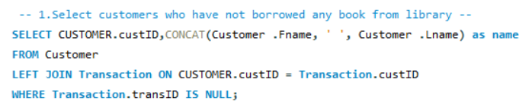

**Output**

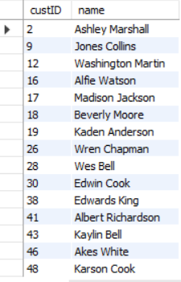

**2. Select book with highest page count**

**RESULT:**

**Query –**

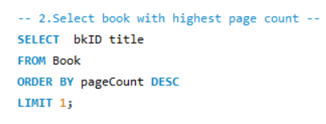

**Output**



**3. Select customer who has borrowed some book for longest period**

**RESULT:**

**Query –**

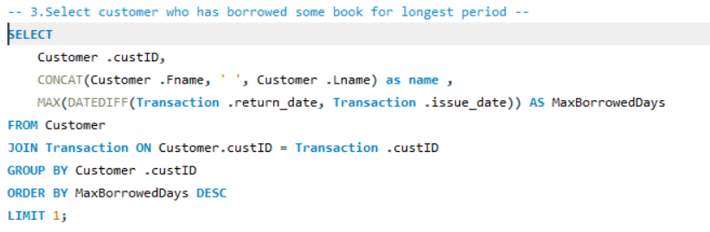

**Output**



**6. JOINS:**

1. **Display list of all books along with their authors**

**RESULT:**

**Query –**

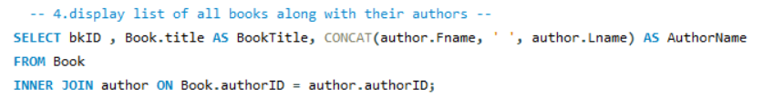

**Output –**

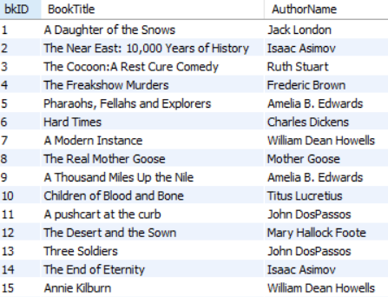

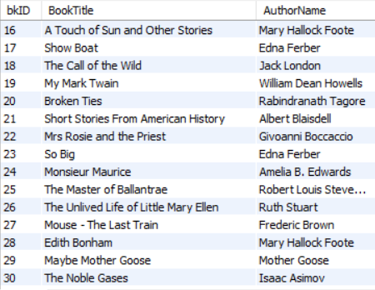

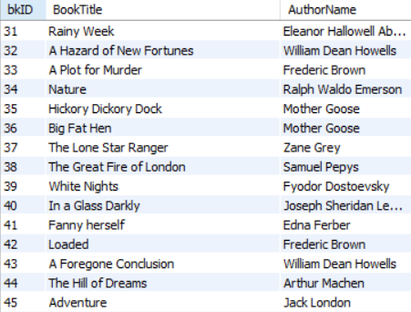

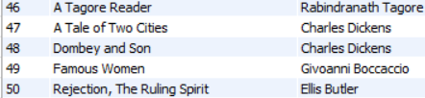

1. **Display list of top 20 most borrowed books**

**RESULT:**

**Query –**

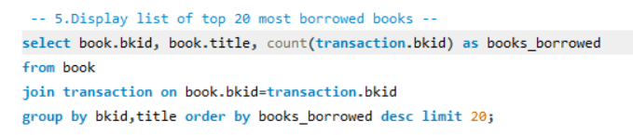

**Output –**

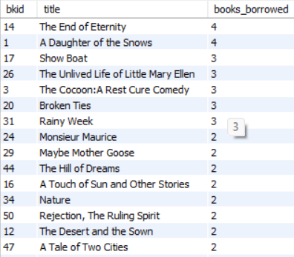

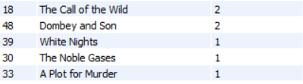

**3. Display list of top 10 customers who have borrowed most books**

**RESULT:**

**Query –**

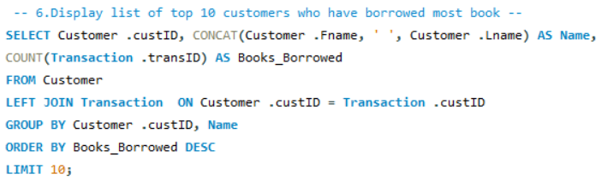

**Output –**

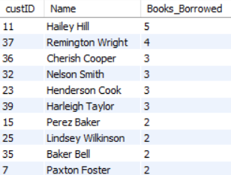

**….THANK YOU….**